Max validation_acc: 0.9355249

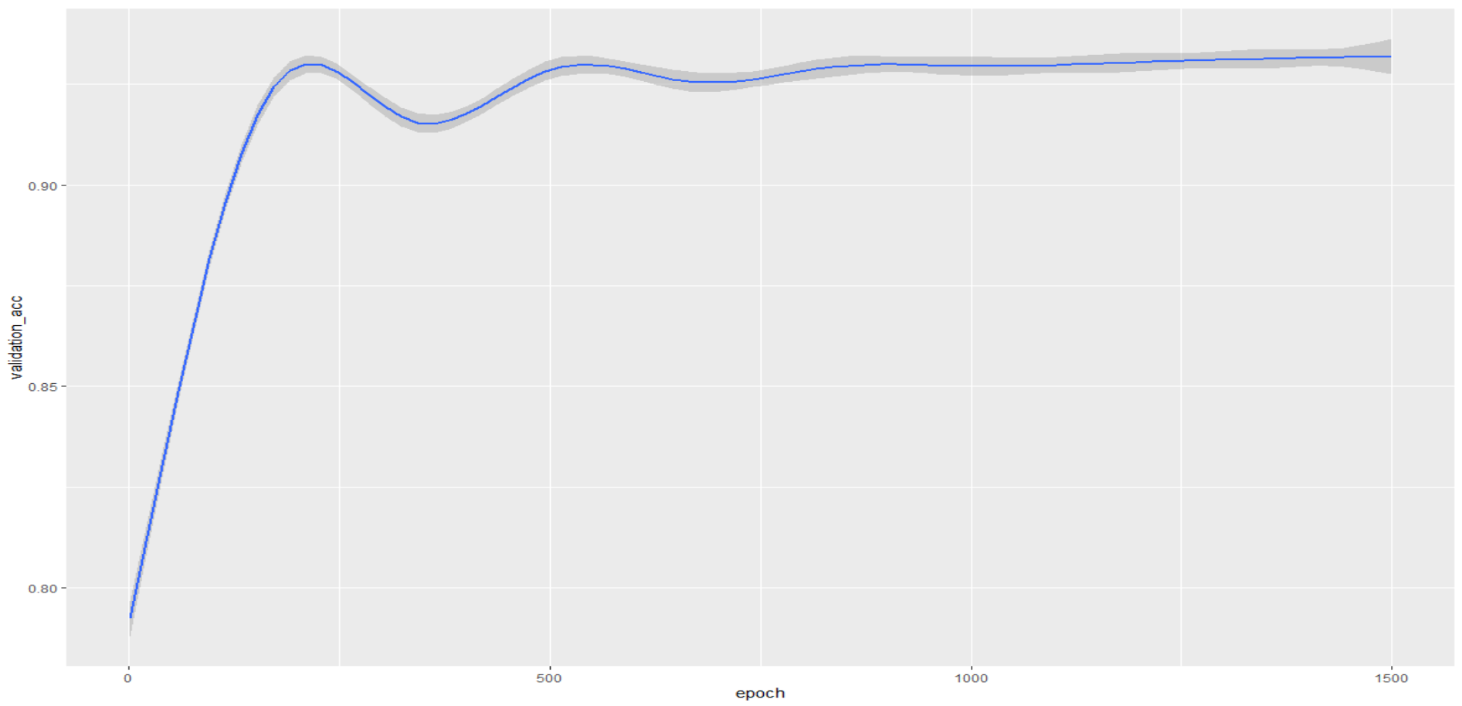

##Cleanup

```{r}

# Check for duplicates

sum(duplicated(data))

# No duplicates

#Remove ID (irrelevant) and FLAG_MOBIL (always 1)

data <- data %>% select(-ID, -FLAG_MOBIL)

cols <- c("CODE_GENDER","FLAG_OWN_CAR","FLAG_OWN_REALTY","NAME_INCOME_TYPE","NAME_EDUCATION_TYPE", "NAME_FAMILY_STATUS", "NAME_HOUSING_TYPE","FLAG_WORK_PHONE","FLAG_PHONE","FLAG_EMAIL", "OCCUPATION_TYPE","status")

cols

data[cols] <- lapply(data[cols],factor)

# Replacing empty values with "Unknown"

levels(data$OCCUPATION_TYPE) <- c(levels(data$OCCUPATION_TYPE), "Unknown")

data$OCCUPATION_TYPE[is.na(data$OCCUPATION_TYPE)] <- "Unknown"

# Replacing C and X in Status

levels(data$status)[levels(data$status)=="C"] <- "6"

#data$status[data$status == "X"] <- 7

levels(data$status)[levels(data$status)=="X"] <- "7"

# #Convert factors into numericals

# data %<>% mutate_if(is.factor, as.numeric)

summary(data)

```

# Preprocessing

```{r Create a recipe for preproc}

set.seed(1)

trainIndex <- initial_split(data, prop = 0.7, strata = status)

trainingSet <- training(trainIndex)

testSet <- testing(trainIndex)

status_folds <- vfold_cv(trainingSet, v = 10, strata = status)

status_folds

```

```{r Create a recipe for preproc2}

set.seed(5)

preprocRecipe <-

recipe(status ~., data = data) %>%

step_dummy(all_nominal(), -status, one_hot = TRUE) %>%

step_range(all_predictors(), -all_nominal(), min = 0, max = 1)%>%

# step_downsample(status, over_ratio = 1) %>%

step_smote(status, over_ratio = 0.5, skip=TRUE) %>%

# step_smotenc(status, over_ratio = 1) %>%

#step_adasyn(status, over_ratio = 1) %>%

#step_nearmiss(status, over_ratio = 1) %>%

step_dummy(status, one_hot = TRUE)# %>%

```

# In this step the above defined receipt is extracted using the `prep()` function, and then use the `bake()` function to transform a set of data based on that recipe.

```{r Prep and bake the defined recipe}

# retain = TRUE and new_data = NULL ensures that pre-processed trainingSet is returned

trainingSet_processed <- preprocRecipe %>%

prep(trainingSet, retain = TRUE) %>%

bake(new_data = NULL)

testSet_processed <- preprocRecipe %>%

prep(testSet) %>%

bake(new_data =testSet)

#summary(trainingSet_processed)

```

## Check data

```{r}

# dim(data)

# sapply(data, class)

# levels(data$status)

#

# #Replace C and X in status

# #data$status[data$status == "C"] <- 6

# levels(data$status)[levels(data$status)=="C"] <- "6"

# #data$status[data$status == "X"] <- 7

# levels(data$status)[levels(data$status)=="X"] <- "7"

# #Convert factors into numericals

# data %<>% mutate_if(is.factor, as.numeric)

# levels(data$status)

# sapply(data, class)

# summarize the class distribution

percentage <- prop.table(table(data$status)) * 100

cbind(freq=table(data$status), percentage=percentage)

# Turn data frame into data matrix

matrix_data <- trainingSet_processed %>% select(-tail(names(trainingSet_processed), 8))

#matrix_data <- subset(data, select = c(CNT_CHILDREN, AMT_INCOME_TOTAL))

#matrix_targets <- data.matrix(trainingSet_processed[])

matrix_targets <- trainingSet_processed %>% select(tail(names(trainingSet_processed), 8))

matrix_data_test <- testSet_processed %>% select(-tail(names(testSet_processed), 8))

matrix_targets_test <- testSet_processed %>% select(tail(names(testSet_processed), 8))

#Subset only 100 entries for testing

#matrix_data <- matrix_data[1:100, ]

#matrix_targets <- matrix_targets[1:100, ]

```

## Build Model

```{r}

#train_data <- matrix_data

train_data <- data.matrix(matrix_data)

test_data <- data.matrix(matrix_data_test)

train_targets <- data.matrix(matrix_targets)

test_targets <- data.matrix(matrix_targets_test)

# Function to build the model

build_model <- function() {

model <- keras_model_sequential() %>%

#layer_batch_normalization(axis = -1L, input_shape = dim(train_data)[[2]]) %>%

layer_dense(units = 64, activation = "relu", input_shape = dim(train_data)[[2]]) %>%

layer_dense(units = 128, activation = "relu") %>%

layer_dense(units = 64, activation = "relu") %>%

layer_dense(units = 8, activation = "softmax")

model %>% compile(

optimizer = optimizer_sgd(learning_rate = 0.2),

loss = "categorical_crossentropy",

metrics = "categorical_accuracy"

)

}

```

## K-Fold-Validation

```{r}

# mean <- apply(matrix_data, 2, mean)

# std <- apply(matrix_data, 2, sd)

# train_data <- scale(matrix_data, center = mean, scale = std)

# test_data <- scale(matrix_data, center = mean, scale = std)

# train_targets <- matrix_targets

k <- 10

indices <- sample(1:nrow(train_data))

folds <- cut(indices, breaks = k, labels = FALSE)

num_epochs <- 1500

all_acc_histories <- NULL

for (i in 1:k) {

cat("processing fold #", i, "\n")

val_indices <- which(folds == i, arr.ind = TRUE)

val_data <- train_data[val_indices,] #test_data#

val_targets <- train_targets[val_indices,] #test_targets#

partial_train_data <- train_data[-val_indices,]

partial_train_targets <- train_targets[-val_indices,]

model <- build_model()

# Train the model (in silent mode, verbose=0)

# Batch size https://stats.stackexchange.com/questions/153531/what-is-batch-size-in-neural-network

# One epoch = one forward pass and one backward pass of all the training examples

# Batch size = the number of training examples in one forward/backward pass. The higher the batch size, the more memory space you'll need.

# Number of iterations = number of passes, each pass using [batch size] number of examples. To be clear, one pass = one forward pass + one backward pass (we do not count the forward pass and backward pass as two different passes).

# Batch size 32 much faster than 1, also the smaller the batch the less accurate the estimate of the gradient will be.

history <- model %>% fit(

partial_train_data, partial_train_targets,

validation_data = list(val_data, val_targets),

epochs = num_epochs, batch_size = 512, verbose = 1

)

acc_history <- history$metrics$val_categorical_accuracy

all_acc_histories <- rbind(all_acc_histories, acc_history)

}

#reticulate::py_last_error()

```